Migration to Phase 2 XT-Streaming.

Multiple Nodes Flow (Tested with 7 Nodes as per the below diagram)

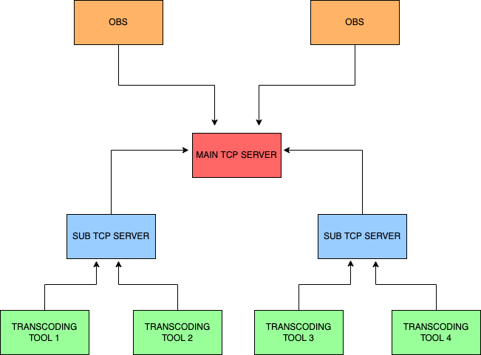

Please Note: For multiple OBS streams, OBS Studio should be in different public network, because OBS IP is used as stream key to fetch the corresponding channel and the live stream. This wont be necessary once stream key is implemented.

1 Main TCP Server

Configuring files in Main_TCP_server

- Open config.json inside Main_TCP_Server directory
- Update the mainServerPort and mainCommPort

1.1 mainServerPort : Port at which obs is get connected to main tcp server
1.2 mainCommPort : Port at which communication between main and sub tcp server

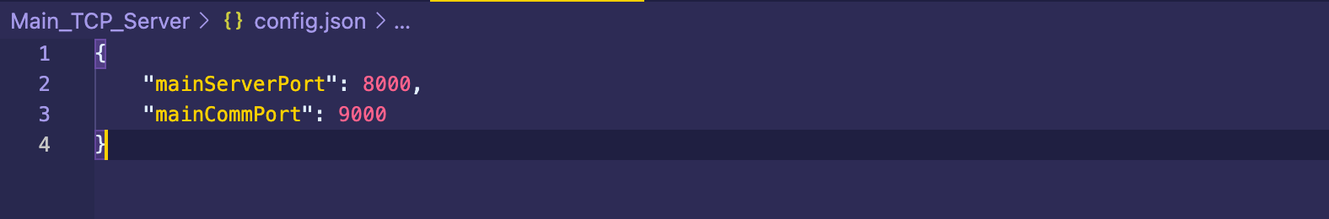
To Run
- Go to root of Main_TCP_Server
- Run following commands
  - docker build -t main .
  - docker run -dp 8000:8000 -p 9000:9000 -- restart=always --name main main

2.Sub TCP Server

Configuring files in Sub_TCP_Server

- Open config.json inside Sub_TCP_Server directory
- Update following values as shown in below image.

2.1 mainTcpServerUrl - URL to the Main_TCP_Server
2.2 mainCommunicationServerPort: communication port between main tcp server and sub tcp server (refer 1.2 mainCommPort)
2.3 internalCommunicationPort: Port at which sub tcp server receives data from main tcp Server
2.4 subCommunicationServerPort: port which used to communicate between sub tcp server and transcoding tool
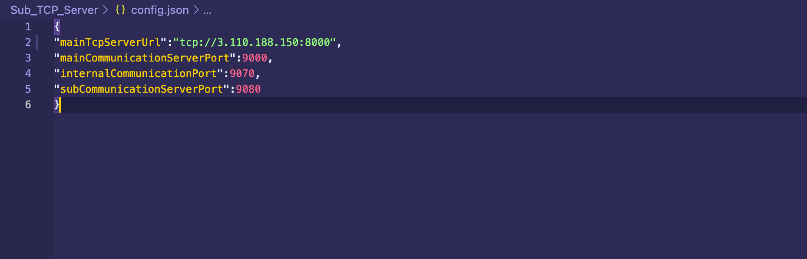
To Run
- Go to root of Sub_TCP_Server
- Run following commands
  - docker build -t sub .
  - docker run -dp 8000:8000 -p 9000:9000 -p 9070:9070 -p 9080:9080 --restart=always --name sub sub

3.Video_transcoding_tool

Configuring video transcoding_tool

- Open config.json inside Sub_TCP_Server directory
- Update following values as shown in the below image.

3.1 broadcastingPort: Port at which the transcoding tool broadcast the stream
3.2 tcp_Server_address: url of the sub tcp server needed to connect
3.3 tcp_communication_port : port at which communication between sub tcp server and transcoding tool take place (refer 2.5 subCommunicationServerPort)
3.4 ipfs:
host: url of IPFS gateway
port: port of IPFS gateway
Protocol:protocol of IPFS gateway
streamConfigPathIpfs: path of stream config file stored in IPFS
(note: if each ipfs node is setup by using main ipfs bootstrap node then ipfs host can be given by main ipfs node gateway or if ipfs cluster is enabled then host gateway will be particular ipfs node )

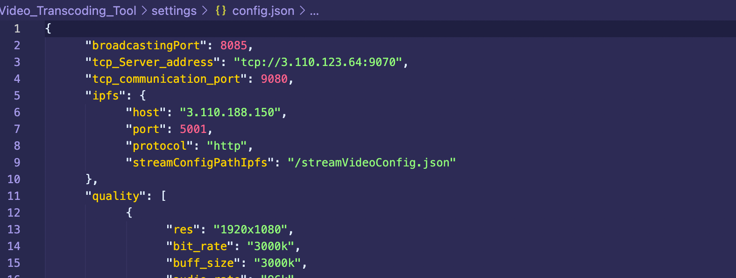

channelName: stream videos are stored in separate directory with channel name as per the user .which needed to updated manually
streamKey: As for now Ip address of the obs client is used as stream key to find the channel name and stream data. which needed to updated manually
streams
streamingName: Name of the streaming video. which should be updated manually
photo_thumbnail: URI of the photo thumbnail. which should be updated manually
video_thumbnail:URI of the video thumbnail. which should be updated manually(not implemented yet)
started_timeStamp: Started time frame of stream which is automatically updated by transcoding tool
ended_timeStamp:Ended time frame of stream which is automatically updated by transcoding tool

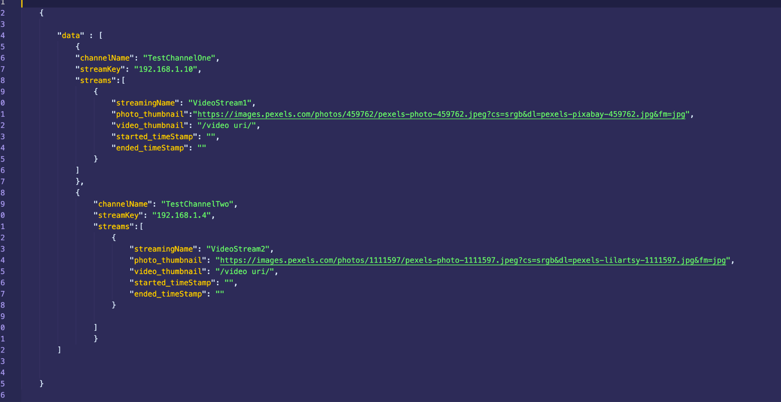

To Run
- Go to root of Video_Transcoding_Tool
- Run following commands
  - docker build -t transcoding .
  - docker run -dp 8085:8085 -v </path/to/media/folder>:/home/node/media --name transcoding --restart=always transcoding

4. VideoPlayer

- Open src/config.json inside VideoPlayer directory
- Update following values as shown in the below image.\

Transcoding_Tool_URL: url to which transcoding tool to connect (webserver)

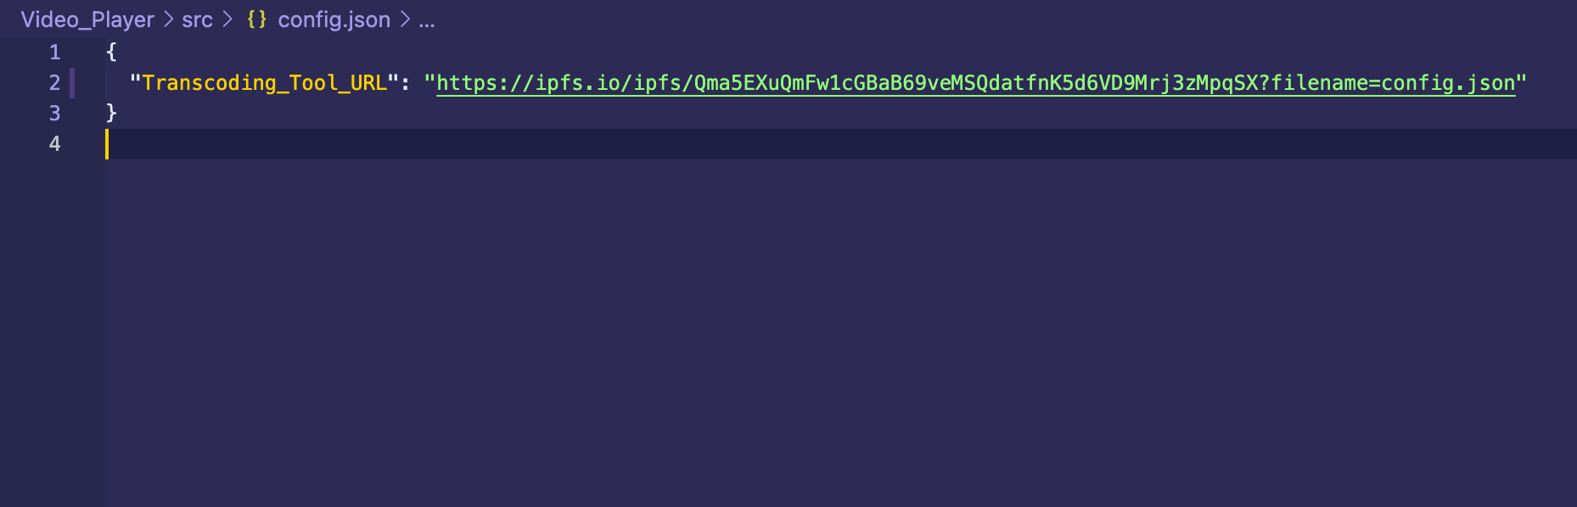

To run VideoPlayer
Refer document 4.1 Instruction for running video player and video-player-chrome-extension

